**Institutional Project Report**

**On**

**“HOSPITAL MANAGEMENT SYSTEM (HMS)”**

Submitted in the Partial fulfillment of the requirement for the Award of Degree of

**Bachelor of Technology**

in

**COMPUTER SCIENCE & ENGINEERING**

Batch

(2017-21)



|  |  |
| --- | --- |
| **Submitted to**    Er.Sarabjeet Singh | **Submitted by**  Shekhar Kashyap (1701367)  Sanchay Khandelwal (1701355)  Prabhnoor singh (1701327)  Sarbjeet Singh (1701360) |

**DEPARTMENT OF COMPUTER SCIENCE & ENGINEERING**

**Amritsar College of Engineering & Technology, Amritsar**

**(Autonomous college under UGC Act – 1956[2(f) and 12(B)] )**

###### ACKNOWLEDGEMENTS

This is a humble effort to express my sincere gratitude towards those who have guided and helped me to complete this project

A project is major milestone during the study period of a student. As such this project was a challenge to me and was an opportunity to prove my caliber. I am highly grateful and obliged to each and everyone making me help out of problems being faced by me.

It would not have been possible to see through the undertaken project without the guidance of **Er.Sarabjeet Singh**. It was purely on the basis of their experience and knowledge that we able to clear all the theoretical and technical hurdles during the development phases of this project work.

Last but not the least I am very thankful to our Head of Department Er. Vinod sharma and all Members of Computer Science Deptt. who gave us an opportunity to face real time problems while fulfilling need of an organization by making projects for them.

**DECLARATION**

We hereby declare that the project work entitled **“Hospital Management System (HMS)”** is an authentic record of my own work carried out as requirements of Institutional Training project for the award of degree of B.Tech(CSE), **Amritsar College of Engg. And Technology, Amritsar,** under the guidance of **Er.Sarabjeet Singh**

(Signature of student)

Name of Student:

Shekhar Kashyap (1701367) Sanchay Khandelwal (1701355)

Prabhnoor singh (1701327)

Sarbjeet Singh (1701360)

Certified that the above statement made by the student is correct to the best of our knowledge

and belief.

**Faculty Coordinator**

Er. Sarabjeet Singh( Associate Professor – CSE Department)

## INDEX PAGE

|  |  |  |
| --- | --- | --- |
| **Sr. No.** | **Content** | **Page No.** |
| 1. | Introduction to the subject | 5 |
| 2. | Introduction to the project | 7 |
| 3. | Project Code | 9 |
| 4. | References | 29 |

## Introduction to RDBMS

RDBMS stands for **R**elational **D**atabase **M**anagement **S**ystem. RDBMS is the basis for SQL, and for all modern database systems like MS SQL Server, IBM DB2, Oracle, MySQL, and Microsoft Access.

A Relational database management system (RDBMS) is a database management system (DBMS) that is based on the relational model as introduced by E. F. Codd.

**Introduction to Table**

The data in an RDBMS is stored in database objects which are called as **tables**. This table is basically a collection of related data entries and it consists of numerous columns and rows.

A record is also called as a row of data is each individual entry that exists in a table.

A column is a vertical entity in a table that contains all information associated with a specific field in a table.

**SQL Constraints**

Constraints are the rules enforced on data columns on a table. These are used to limit the type of data that can go into a table. This ensures the accuracy and reliability of the data in the database.

Constraints can either be column level or table level. Column level constraints are applied only to one column whereas, table level constraints are applied to the entire table.

Following are some of the most commonly used constraints available in SQL −

* [NOT NULL Constraint](https://www.tutorialspoint.com/sql/sql-not-null.htm) − Ensures that a column cannot have a NULL value.
* [DEFAULT Constraint](https://www.tutorialspoint.com/sql/sql-default.htm) − Provides a default value for a column when none is specified.
* [UNIQUE Constraint](https://www.tutorialspoint.com/sql/sql-unique.htm) − Ensures that all the values in a column are different.
* [PRIMARY Key](https://www.tutorialspoint.com/sql/sql-primary-key.htm) − Uniquely identifies each row/record in a database table.
* [FOREIGN Key](https://www.tutorialspoint.com/sql/sql-foreign-key.htm) − Uniquely identifies a row/record in any another database table.
* [CHECK Constraint](https://www.tutorialspoint.com/sql/sql-check.htm) − The CHECK constraint ensures that all values in a column satisfy certain conditions.
* [INDEX](https://www.tutorialspoint.com/sql/sql-index.htm) − Used to create and retrieve data from the database very quickly.

**Database Normalization**

Database normalization is the process of efficiently organizing data in a database. There are two reasons of this normalization process −

* Eliminating redundant data, for example, storing the same data in more than one table.
* Ensuring data dependencies make sense.

Both these reasons are worthy goals as they reduce the amount of space a database consumes and ensures that data is logically stored. Normalization consists of a series of guidelines that help guide you in creating a good database structure.

Normalization guidelines are divided into normal forms; think of a form as the format or the way a database structure is laid out. The aim of normal forms is to organize the database structure, so that it complies with the rules of first normal form, then second normal form and finally the third normal form.

It is your choice to take it further and go to the fourth normal form, fifth normal form and so on, but in general, the third normal form is more than enough.

* [First Normal Form (1NF)](https://www.tutorialspoint.com/sql/first-normal-form.htm)
* [Second Normal Form (2NF)](https://www.tutorialspoint.com/sql/second-normal-form.htm)
* [Third Normal Form (3NF)](https://www.tutorialspoint.com/sql/third-normal-form.htm)

**FEATURES OF RDBMS:**

The system caters to a wide variety of applications and quite a few of its stand out features enable its worldwide use. The features include:

1. First of all, its number one feature is the ability to store data in tables. The fact that the very storage of data is in a structured form can significantly reduce iteration time.
2. Data persists in the form of rows and columns and allows for a facility primary key to define unique identification of rows.
3. It creates indexes for quicker data retrieval.
4. Allows for various types of data integrity like
   1. **Entity Integrity :** wherein no duplicate rows in a table exist
   2. **Domain Integrity :** that enforces valid entries for a given column by filtering the type, the format, or the wide use of values
   3. **Referential Integrity :** which disables the deletion of rows that are in use by other records and
   4. **User Defined Integrity :** providing some specific business rules that do not fall into the above three.
5. Also allows for the virtual table creation which provides a safe means to store and secure sensitive content.
6. Common column implementation and also multi user accessibility is included in the RDBMS features.

## INTRODUCTION TO THE PROJECT

A **hospital management system** (HMS) is a computer or web based system that facilitates managing the functioning of the hospital or any medical set up1. This system or software will help in making the whole functioning paperless. It integrates all the information regarding patients, doctors, staff, hospital administrative details etc. into one software. It has sections for various professionals that make up a hospital.

**Doctors**

This section includes the list of the doctors and their schedules. It also includes doctors’ emergency numbers. The patient can be given an appointment referring to the doctors’ schedule. The use of HMS makes the co-ordination between a doctor and patient easy and hassle free.

**Patient information**

New patients can be registered in the system. An  medical record system is in-built which stores all the basic and medical details of the patient

**Staff Information**

New staff can be registered in the system. A record system is in-built which stores all the basic and necessary details of the staff

**Benefits of implementing a hospital management system:**

* **Appointment booking**
  + Helps patients cut the long queue and saves their time
* **Role-Based Access Control**
  + Allows employees to access only the necessary information to effectively perform their job duties
  + Increases data security and integrity
* **Overall cost reduction**
  + Cuts down paper costs as all the data are computerised
  + No separate costs for setting up physical servers
* **Data accuracy**
  + Removes human errors
  + Alerts when there’s a shortage of stock
* **Data security**
  + Helps to keep patients records private
  + Restricts access through role-based access control
* **Revenue management**
  + Makes daily auditing simple
  + Helps with statistics and other financial aspects

**Source Code**

**import** mysql.connector  
**from** datetime **import** date  
**from** tkinter **import** *  
**from** PIL **import** Image,ImageTk  
  
mydb=mysql.connector.connect(host=**'localhost'**,user=**'root'**,passwd=**'shekhar'**,database=**'hospital_management'**)  
today=date.today()  
mycursor=mydb.cursor()  
**def** close1():  
 exit()  
**def** close():  
 starting()  
**def** deleted1():  
 query = **"delete from staff_infor where name_pat='{}'"**.format(str(stname))  
 mycursor.execute(query)  
 mydb.commit()  
 staff()  
**def** updated1():  
 value_up4 = **"update staff_infor set name_pat=%s,gender=%s,age=%s,phone=%s,address=%s,job_name=%s,salary=%s where name_pat='{}'"**.format(str(stname))  
 value_time4 = (stname21.get(), stgender21.get(),stage21.get(),stphone21.get(), staddress21.get(), qual21.get(),sal21.get())  
 mycursor.execute(value_up4, value_time4)  
 mydb.commit()  
 staff()  
**def** added1():  
  
 valuef = **"insert into staff_infor(rid_no,name_pat,gender,age,phone,address,job_name,salary,date_reg)values(%s,%s,%s,%s,%s,%s,%s,%s,%s)"** valuef1 = (stid21.get(), stname21.get(), stgender21.get(),stage21.get(),stphone21.get(), staddress21.get(), qual21.get(),sal21.get(),jdate21.get())  
 *# print(value1)* mycursor.execute(valuef, valuef1)  
 mydb.commit()  
 staff()  
  
**def** data1():  
 **global** stname  
 stname4 = stname2.get()  
 strid4 = strid2.get()  
 **if** stname4 == **""**:  
 mycursor.execute(**"select name_pat from staff_infor where rid_no ='{}'"**.format(str(strid4)))  
 **elif** strid4 == **""**:  
 mycursor.execute(**"select name_pat from staff_infor where name_pat='{}'"**.format(str(stname4)))  
 **else**:  
 mycursor.execute(**"select name_pat from staff_infor where name_pat='{}'and rid_no='{}'"**.format(str(stname4), str(strid4)))  
  
 myresult = mycursor.fetchone()  
 **for** i **in** myresult:  
 lb2.insert(ACTIVE, **f"{**i**}"**)  
  
 stname = lb2.get(ACTIVE)  
 mycursor.execute(**"select rid_no,name_pat,gender,age,phone,address,job_name,salary,date_reg from staff_infor where name_pat='{}'"**.format(str(stname)))  
 myresult = mycursor.fetchone()  
 stid21.set(myresult[0])  
 stname21.set(myresult[1])  
 stgender21.set(myresult[2])  
 stage21.set(myresult[3])  
 stphone21.set(myresult[4])  
 staddress21.set(myresult[5])  
 qual21.set(myresult[6])  
 sal21.set(myresult[7])  
 jdate21.set(myresult[8])  
  
  
**def** staff():  
 **global** stname2,strid2,lb2,stage21,stname21,stid21,stgender21,qual21,sal21,stphone21,staddress21,jdate21  
 f6 = Frame(window, borderwidth=10, bg=**"white"**)  
 f6.grid(row=5, column=0)  
 f6.place(x=400, y=100)  
 l = Label(f6, text=**"\n\n\n"**, bg=**"white"**).grid()  
 l30 = Label(f6, text=**"Staff's Name"**, bg=**"white"**, font=20).grid(row=0, column=0)  
 stname2 = StringVar()  
 stname3 = Entry(f6, textvariable=stname2).grid(row=1, column=0)  
 l = Label(f6, text=**"\n\n\n"**, bg=**"white"**).grid()  
 l31a = Label(f6, text=**"Staff's Registeration ID"**, bg=**"white"**, font=10).grid(row=2, column=0)  
 strid2 = StringVar()  
 strid3 = Entry(f6, textvariable=strid2).grid(row=3, column=0)  
 but = Button(f6, text=**"Search"**,font=20,bg=**"blue"**, command=data1).grid(row=4, column=0)  
 *#l32 = Label(f6, text="\n\n", bg="blue", font=20).grid(row=5, column=0)* lb2 = Listbox(f6, width=20)  
 lb2.grid(row=6, column=0)  
 l39 = Label(f6, text=**"\t\t"**, bg=**"white"**, font=20).grid(row=0, column=2)  
 l33 = Label(f6, text=**"ID"**, bg=**"white"**, font=20).grid(row=0, column=3)  
 stid21 = StringVar()  
 mycursor.execute(**"select count(*) from staff_infor"**)  
 myresultn = mycursor.fetchone()  
 **for** row **in** myresultn:  
 abc = row  
 abc += 1  
 stid21.set(abc)  
 stid1 = Entry(f6, textvariable=stid21).grid(row=0, column=6)  
 l37 = Label(f6, text=**"Joining Date"**, bg=**"white"**, font=20).grid(row=1, column=3)  
 jdate21 = StringVar()  
 jdate21.set(today)  
 jdate1 = Entry(f6, textvariable=jdate21).grid(row=1, column=6)  
 l34 = Label(f6, text=**"Name"**, bg=**"white"**, font=20).grid(row=3, column=3)  
 stname21 = StringVar()  
 stname1 = Entry(f6, textvariable=stname21).grid(row=3, column=6)  
 l35 = Label(f6, text=**"Gender"**, bg=**"white"**, font=20).grid(row=4, column=3)  
 stgender21 = StringVar()  
 stgender1 = Entry(f6, textvariable=stgender21).grid(row=4, column=6)  
 l36 = Label(f6, text=**"Age"**, bg=**"white"**, font=20).grid(row=5, column=3)  
 stage21 = StringVar()  
 stage1 = Entry(f6, textvariable=stage21).grid(row=5, column=6)  
 l39 = Label(f6, text=**"Job"**, bg=**"white"**, font=20).grid(row=6, column=3)  
 qual21 = StringVar()  
 qual1 = Entry(f6, textvariable=qual21).grid(row=6, column=6)  
 l38 = Label(f6, text=**"Salary"**, bg=**"white"**, font=20).grid(row=7, column=3)  
 sal21 = StringVar()  
 sal1 = Entry(f6, textvariable=sal21).grid(row=7, column=6)  
 l37 = Label(f6, text=**"Phone"**, bg=**"white"**, font=20).grid(row=8, column=3)  
 stphone21 = StringVar()  
 stphone1 = Entry(f6, textvariable=stphone21).grid(row=8, column=6)  
 l38 = Label(f6, text=**"Address"**, bg=**"white"**, font=20).grid(row=9, column=3)  
 staddress21 = StringVar()  
 staddress1 = Entry(f6, textvariable=staddress21).grid(row=9, column=6)  
  
 l39 = Label(f6, text=**"\t\t"**, bg=**"white"**, font=20).grid(row=0, column=14)  
 b11 = Button(f6, text=**" Add "**,font=20,bg=**"blue"**,command=added1).grid(row=2, column=20)  
 b12 = Button(f6, text=**"Update "**,font=20,bg=**"blue"**,command=updated1).grid(row=4, column=20)  
 b13 = Button(f6, text=**"Delete "**,font=20,bg=**"blue"**,command=deleted1).grid(row=6, column=20)  
 b14 = Button(f6, text=**"Close "**,font=20,bg=**"blue"**,command=close).grid(row=8, column=20)  
 tem = Label(f6, text=**"\n\n\n\n\n\n\t\t\t\t\t"**, bg=**"white"**).grid()  
  
**def** deleted():  
 query=**"delete from patient_reg where name_pat='{}'"**.format(str(ptname))  
 mycursor.execute(query)  
 mydb.commit()  
 query1=**"delete from room_infor where name_pat='{}'"**.format(str(ptname))  
 mycursor.execute(query1)  
 mydb.commit()  
 pat_info1()  
**def** updated():  
 value_up=**"update patient_reg set name_pat=%s,gender=%s,age=%s,phone=%s,address=%s,disease=%s,sod=%s where name_pat='{}'"**.format(str(ptname))  
 value_time=(name21.get(),gender21.get(),age21.get(),phone21.get(),address21.get(),disease21.get(),sod21.get())  
 mycursor.execute(value_up, value_time)  
 mydb.commit()  
 value_up1 = **"update room_infor set name_pat=%s,building=%s,room_type=%s,room_no=%s where name_pat='{}'"**.format(str(ptname))  
 value_time1=(name21.get(),building21.get(),rtype21.get(),rno21.get())  
 mycursor.execute(value_up1,value_time1)  
 mydb.commit()  
 pat_info()  
**def** added():  
 value = **"insert into patient_reg(rid_no,date_reg,pid,name_pat,gender,age,phone,address,disease,sod)values(%s,%s,%s,%s,%s,%s,%s,%s,%s,%s)"** value1 = (no.get(),date.get(),pid.get(),name.get(),gender.get(),age.get(),phone.get(),address.get(),disease.get(),sod.get())  
 *#print(value1)* mycursor.execute(value,value1)  
 mydb.commit()  
 value2=**"insert into room_infor(rid_no,name_pat,building,room_type,room_no,room_price)values(%s,%s,%s,%s,%s,%s)"** value3=(no.get(),name.get(),building.get(),rtype.get(),rno.get(),price.get())  
 mycursor.execute(value2, value3)  
 mydb.commit()  
 pat_reg()  
  
**def** data():  
 **global** ptname  
 pname4=pname2.get()  
  
 rid4=rid2.get()  
 **if** pname4==**""**:  
 mycursor.execute(**"select name_pat from patient_reg where rid_no ='{}'"**.format(str(rid4)))  
 **elif** rid4==**""**:  
 mycursor.execute(**"select name_pat from patient_reg where name_pat='{}'"**.format(str(pname4)))  
 **else**:  
 mycursor.execute(**"select name_pat from patient_reg where name_pat='{}'and rid_no='{}'"**.format(str(pname4),str(rid4)))  
 myresult = mycursor.fetchone()  
 **for** i **in** myresult:  
 lb1.insert(ACTIVE,**f"{**i**}"**)  
  
 ptname=lb1.get(ACTIVE)  
  
 mycursor.execute(**"select pid,name_pat,gender,age,phone,address,disease,sod,date_reg from patient_reg where name_pat='{}'"**.format(str(ptname)))  
 myresult = mycursor.fetchone()  
 pid21.set(myresult[0])  
 name21.set(myresult[1])  
 gender21.set(myresult[2])  
 age21.set(myresult[3])  
 phone21.set(myresult[4])  
 address21.set(myresult[5])  
 disease21.set(myresult[6])  
 sod21.set(myresult[7])  
 date21.set(myresult[8])  
  
 mycursor.execute(**"select building,room_type,room_no from room_infor where name_pat='{}'"**.format(str(ptname)))  
 myresult1 = mycursor.fetchone()  
 building21.set(myresult1[0])  
 rtype21.set(myresult1[1])  
 rno21.set(myresult1[2])  
  
**def** pat_info1():  
 pat_info()  
 l12 = Label(f4, text=**"Check Out"**, bg=**"white"**, font=20).grid(row=7, column=9)  
 dateout = StringVar()  
 dateout.set(today)  
 date2 = Entry(f4, textvariable=dateout).grid(row=7, column=12)  
  
 b9 = Button(f4, text=**" Delete "**,font=20,bg=**"blue"**, command=deleted).grid(row=8, column=12)  
 b10 = Button(f4, text=**"Close"**,font=20,bg=**"blue"**,command=close).grid(row=8, column=14)  
  
  
  
**def** pat_info():  
 **global** f4,rid2,pname2,lb1,pid21,name21,gender21,age21,phone21,address21,disease21,sod21,building21,rno21,rtype21,date21  
 f4 = Frame(window, borderwidth=10, bg=**"white"**)  
 f4.grid(row=5, column=0)  
 f4.place(x=400, y=100)  
 l = Label(f4, text=**"\n\n\n"**,bg=**"white"**).grid()  
 l27 = Label(f4, text=**"Patient's Name"**, bg=**"white"**,font=20).grid(row=0, column=0)  
 pname2= StringVar()  
 pname3 = Entry(f4, textvariable=pname2).grid(row=1, column=0)  
 l=Label(f4,text=**"\n\n\n"**,bg=**"white"**).grid()  
 l27a = Label(f4, text=**"Patient's Registeration ID"**, bg=**"white"**, font=10).grid(row=2, column=0)  
 rid2 = StringVar()  
 rid3 = Entry(f4, textvariable=rid2).grid(row=3, column=0)  
 but = Button(f4, text=**"Search"**,font=20,bg=**"blue"**,command=data).grid(row=4, column=0)  
 l27 = Label(f4, text=**"\n\n"**, bg=**"white"**, font=20).grid(row=5, column=0)  
 lb1 = Listbox(f4, width=20)  
 lb1.grid(row=6, column=0)  
 l14 = Label(f4, text=**"PID"**, bg=**"white"**, font=20).grid(row=2, column=3)  
 pid21 = StringVar()  
 pid1 = Entry(f4, textvariable=pid21).grid(row=2, column=6)  
 l12 = Label(f4, text=**"Name"**, bg=**"white"**, font=20).grid(row=3, column=3)  
 name21 = StringVar()  
 name1 = Entry(f4, textvariable=name21).grid(row=3, column=6)  
 l15 = Label(f4, text=**"Gender"**, bg=**"white"**, font=20).grid(row=4, column=3)  
 gender21 = StringVar()  
 gender1 = Entry(f4, textvariable=gender21).grid(row=4, column=6)  
 l16 = Label(f4, text=**"Age"**, bg=**"white"**, font=20).grid(row=5, column=3)  
 age21 = StringVar()  
 age1 = Entry(f4, textvariable=age21).grid(row=5, column=6)  
 l17 = Label(f4, text=**"Phone"**, bg=**"white"**, font=20).grid(row=6, column=3)  
 phone21 = StringVar()  
 phone1 = Entry(f4, textvariable=phone21).grid(row=6, column=6)  
 l18 = Label(f4, text=**"Address"**, bg=**"white"**, font=20).grid(row=7, column=3)  
 address21 = StringVar()  
 address1 = Entry(f4, textvariable=address21).grid(row=7, column=6)  
 l19 = Label(f4, text=**"Disease"**, bg=**"white"**, font=20).grid(row=8, column=3)  
 disease21 = StringVar()  
 disease1 = Entry(f4, textvariable=disease21).grid(row=8, column=6)  
 lt5=Label(f4,text=**"\t\t\t\t\t\t"**,bg=**"white"**).grid(row=2,column=9)  
 l20 = Label(f4, text=**"Status Of Disease"**, bg=**"white"**, font=20).grid(row=2, column=9)  
 sod21 = StringVar()  
 sod1 = Entry(f4, textvariable=sod21).grid(row=2, column=12)  
 l23 = Label(f4, text=**"Building"**, bg=**"white"**, font=20).grid(row=3, column=9)  
 building21 = StringVar()  
 building1 = Entry(f4, textvariable=building21).grid(row=3, column=12)  
 l24 = Label(f4, text=**"Room No."**, bg=**"white"**, font=20).grid(row=4, column=9)  
 rno21 = StringVar()  
 rno1 = Entry(f4, textvariable=rno21).grid(row=4, column=12)  
 l25 = Label(f4, text=**"Room Type"**, bg=**"white"**, font=20).grid(row=5, column=9)  
 rtype21 = StringVar()  
 rtype1 = Entry(f4, textvariable=rtype21).grid(row=5, column=12)  
 l26 = Label(f4, text=**"Check In"**, bg=**"white"**, font=20).grid(row=6, column=9)  
 date21 = StringVar()  
 date1 = Entry(f4, textvariable=date21).grid(row=6, column=12)  
 b9 = Button(f4, text=**"Update"**,bg=**"blue"**, command=updated,font=20).grid(row=8, column=12)  
 b10 = Button(f4, text=**"Close"**,font=20,bg=**"blue"**,command=close).grid(row=8, column=14)  
 tem = Label(f4, text=**"\n\n\n\n\n\n\t\t\t\t\t"**, bg=**"white"**).grid()  
 *#b3 = Button(f4, text=" Add ", font=20, command=added).grid(row=14, column=12)  
 #b3 = Button(f4, text="Close", font=20).grid(row=14, column=14)***def** pat_reg():  
 **global** no,date,pid,name,gender,age,phone,address,disease,sod,rtype,building,rno,rtype3,price  
 f3 = Frame(window, borderwidth=5, bg=**"white"**)  
 f3.grid(row=5, column=0)  
 f3.place(x=400, y=100)  
 t = Label(f3, text=**"\n\n\n\n"**, bg=**"white"**).grid()  
 l11=Label(f3,text=**"Registration ID"**,bg=**"white"**,font=20).grid(row=6,column=0)  
 t = Label(f3, text=**"\n"**, bg=**"white"**).grid()  
 l12 = Label(f3, text=**"No."**, bg=**"white"**, font=20).grid(row=8, column=0)  
 no=StringVar()  
 mycursor.execute(**"select count(*) from patient_reg"**)  
 myresult = mycursor.fetchone()  
 **for** row **in** myresult:  
 a= row  
 a += 1  
 no.set(a)  
  
 no1=Entry(f3,textvariable=no).grid(row=8,column=3)  
 l12 = Label(f3, text=**"Date"**, bg=**"white"**, font=20).grid(row=10, column=0)  
 date=StringVar()  
 date.set(today)  
 date2=Entry(f3,textvariable=date).grid(row=10,column=3)  
 *#lt = Label(f3, text="", bg="blue").grid()* l13=Label(f3,text=**"Patient's Information"**,bg=**"white"**,font=20).grid(row=15,column=0)  
 lt=Label(f3,text=**"\n"**,bg=**"white"**).grid()  
 l14 = Label(f3, text=**"PID"**, bg=**"white"**, font=20).grid(row=24, column=0)  
 pid=StringVar()  
 mycursor.execute(**"SELECT pid FROM patient_reg where date_reg='{}' ORDER BY pid DESC LIMIT 1"**.format(str(today)))  
 myresult = mycursor.fetchone()  
 **if** myresult **is None**:  
 b=0  
 **else**:  
 **for** i **in** myresult:  
 b=i  
 b+=1  
 pid.set(b)  
 pid1 = Entry(f3, textvariable=pid).grid(row=24, column=3)  
  
 l12 = Label(f3, text=**"Name"**, bg=**"white"**, font=20).grid(row=28, column=0)  
 name = StringVar()  
 name1 = Entry(f3, textvariable=name).grid(row=28, column=3)  
  
 l15 = Label(f3, text=**"Gender"**, bg=**"white"**, font=20).grid(row=32, column=0)  
 gender= StringVar()  
 gender1 = Entry(f3, textvariable=gender).grid(row=32, column=3)  
  
 l16 = Label(f3, text=**"Age"**, bg=**"white"**, font=20).grid(row=36, column=0)  
 age= StringVar()  
 age1 = Entry(f3, textvariable=age).grid(row=36, column=3)  
  
 l17 = Label(f3, text=**"Phone"**, bg=**"white"**, font=20).grid(row=40, column=0)  
 phone = StringVar()  
 phone1 = Entry(f3, textvariable=phone).grid(row=40, column=3)  
  
 l18 = Label(f3, text=**"Address"**, bg=**"white"**, font=20).grid(row=44, column=0)  
 address = StringVar()  
 address1 = Entry(f3, textvariable=address).grid(row=44, column=3,ipady=20)  
  
 l19 = Label(f3, text=**"Disease"**, bg=**"white"**, font=20).grid(row=48, column=0)  
 disease = StringVar()  
 disease1 = Entry(f3, textvariable=disease).grid(row=48, column=3)  
 l20 = Label(f3, text=**"Status Of Disease"**, bg=**"white"**, font=20).grid(row=52, column=0)  
 sod= StringVar()  
 sod1 = Entry(f3, textvariable=sod).grid(row=52, column=3)  
 t = Label(f3, text=**"\n\n\n\n"**, bg=**"white"**).grid(row=0,column=14)  
 t = Label(f3, text=**"\t\t\t\t\t\t\t"**, bg=**"white"**).grid(row=0, column=14)  
 l21 = Label(f3, text=**"Room Type"**, bg=**"white"**,font=20).grid(row=6, column=14)  
 rtype=StringVar()  
 rtype1=Radiobutton(f3,text=**"Normal"**,variable=rtype,value=**"Normal"**,bg=**"white"**,font=20).grid(row=8,column=14)  
 rtype2=Radiobutton(f3,text=**"Medium"**,variable=rtype,value=**"Medium"**,bg=**"white"**,font=20).grid(row=9,column=14)  
 rtype4=Radiobutton(f3,text=**"VIP "**,variable=rtype,value=**"VIP"**,justify=LEFT, bg=**"white"**, font=20).grid(row=10, column=14)  
 *# t = Label(f3, text="\n\n\n\n", bg="blue").grid(row=0, column=16)* l22 = Label(f3, text=**"Room's Information"**, bg=**"white"**, font=20).grid(row=6, column=16)  
 l23 = Label(f3, text=**"Building"**, bg=**"white"**, font=20).grid(row=8, column=16)  
 building = StringVar()  
 building1 = Entry(f3, textvariable=building).grid(row=8, column=18)  
 l24 = Label(f3, text=**"Room No."**, bg=**"white"**,font=20).grid(row=9, column=16)  
 rno = StringVar()  
 rno1 = Entry(f3, textvariable=rno).grid(row=9, column=18)  
 l25 = Label(f3, text=**"Room Type"**, bg=**"white"**, font=20).grid(row=10, column=16)  
 rtype3 = StringVar()  
 rtype12 = Entry(f3, textvariable=rtype3).grid(row=10, column=18)  
 l26 = Label(f3, text=**"Price"**, bg=**"white"**, font=20).grid(row=11, column=16)  
 price = StringVar()  
 price1 = Entry(f3, textvariable=price).grid(row=11, column=18)  
 b3=Button(f3,text=**" Add "**,font=20,bg=**"blue"**,command=added).grid(row=14,column=16)  
 b3 = Button(f3, text=**"Close"**, font=20,bg=**"blue"**,command=close).grid(row=14, column=18)  
  
**def** logged():  
 **if** uservalue.get()==**"project" and** passvalue.get()==**"rdbms"**:  
 root.destroy()  
 **global** window  
 window=Tk()  
 window.geometry(**"1550x850"**)  
 window.title(**"ABC Hospital"**)  
 starting()  
**def** starting():  
 f2= Frame(window, borderwidth=10, bg=**"blue"**)  
  
 f2.grid(row=5, column=0)  
 f2.place(x=0, y=70)  
 image = Image.open(**r"C:\Users\Shekhar\Desktop\Certificate\abc.jpg"**)  
 img = image.resize((1280,700))  
 photo = ImageTk.PhotoImage(img)  
 label1 = Label(image=photo)  
 label1.grid()  
 label1.place(x=252, y=75)  
 l1=Label(window,text=**"ABC Hospital\t\t\t\t\t\t\t\t\t\t\t\t\t"**,foreground=**"white"**,bg=**"blue"**,font=(**"Helvetica"**, 20, **"bold "**),pady=20).grid(row=0,column=0)  
 *#l10 = Label(f2, text="\n\n", bg="blue", font=10).grid()* b1=Button(f2, text=**"Patient Registration "**,bg=**"blue"**,borderwidth=10,relief=GROOVE,font=15,command=pat_reg).grid(row=0,column=0)  
 l10= Label(f2, text=**"\n\n\n"**, bg=**"blue"**, font=10).grid()  
 b3=Button(f2, text=**"Patient Information "**,bg=**"blue"**,borderwidth=10,relief=GROOVE,font=15,command=pat_info).grid(row=8,column=0)  
 l10 = Label(f2, text=**"\n\n\n"**, bg=**"blue"**, font=10).grid()  
 b4=Button(f2, text=**"Patient CheckOut "**,bg=**"blue"**,borderwidth=10,relief=GROOVE,font=15,command=pat_info1).grid(row=12,column=0)  
 l10 = Label(f2, text=**"\n\n\n"**, bg=**"blue"**, font=10).grid()  
 b7=Button(f2, text=**"Staff Information "**,bg=**"blue"**,borderwidth=10,relief=GROOVE,font=15,command=staff).grid(row=24,column=0)  
 l10 = Label(f2, text=**"\n\n\n"**, bg=**"blue"**, font=10).grid()  
 b7 = Button(f2, text=**"Close "**, bg=**"blue"**, borderwidth=10, relief=GROOVE, font=15,command=close1).grid(row=28, column=0)  
 lt = Label(f2, text=**"\n\n"**,bg=**"blue"**).grid()  
 *#b7 = Button(f2, text="Close ", bg="blue", borderwidth=10, relief=GROOVE, font=15).grid(row=28, column=1)* window.mainloop()  
  
  
root=Tk()  
root.geometry(**"1550x850"**)  
root.title(**"ABC Hospital"**)  
image = Image.open(**r"C:\Users\Shekhar\Desktop\Certificate\2.jpg"**)  
img = image.resize((1550, 850))  
photo = ImageTk.PhotoImage(img)  
label1 = Label(image=photo)  
label1.grid()  
label1.place(x=0, y=0)  
f1=Frame(root,borderwidth=20,bg=**"white"**,relief=GROOVE)  
f1.grid(row=5,column=0)  
f1.place(x=900, y=350)  
l0=Label(f1,text=**" "**,bg=**"white"**).grid(row=0,column=0)  
l2=Label(f1,text=**"User Name:"**,bg=**"white"**,font=20)  
l2.grid(row=6,column=0)  
uservalue=StringVar()  
passvalue=StringVar()  
userentry=Entry(f1,textvariable=uservalue).grid(row=6,column=1)  
l5=Label(f1,text=**"\n"**,bg=**"white"**,font=20)  
l5.grid()  
l3=Label(f1,text=**"Password:"**,bg=**"white"**,font=20)  
l3.grid(row=8,column=0)  
passentry=Entry(f1,show=**"*"**,textvariable=passvalue).grid(row=8,column=1)  
l4=Label(f1,text=**"\n\t\t"**,bg=**"white"**,font=20)  
l4.grid()  
b1=Button(f1,text=**"Log-in"**,font=**"12"**,bg=**"blue"**,command=logged).grid(row=11,column=1)  
b2=Button(f1,text=**"Exit "**,font=**"12"**,bg=**"blue"**,command=close1).grid(row=11,column=3)  
l4=Label(f1,text=**"\n\t"**,bg=**"white"**,font=20).grid(row=11,column=4)  
root.mainloop()

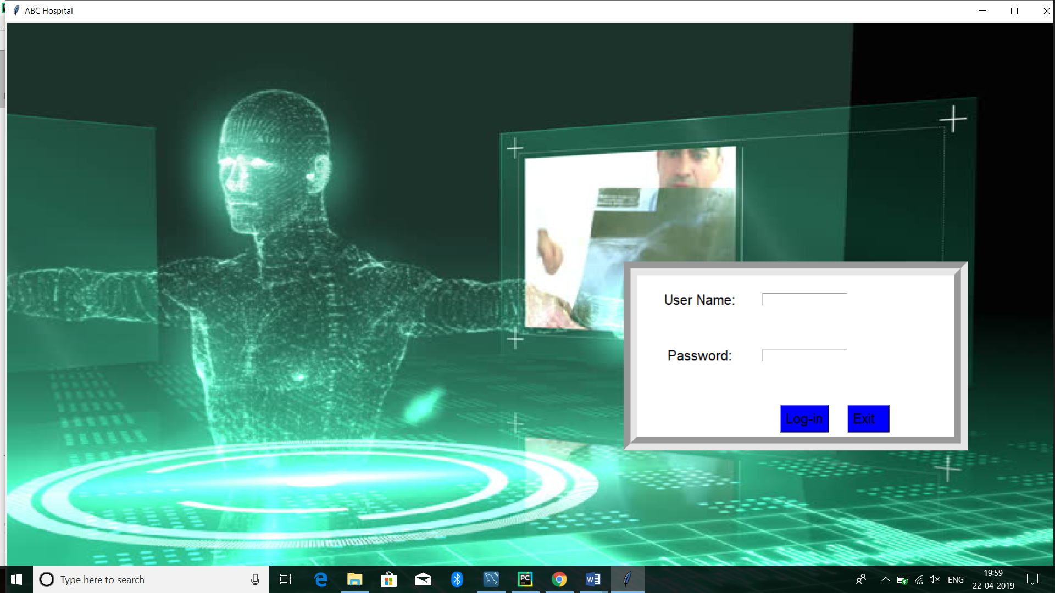

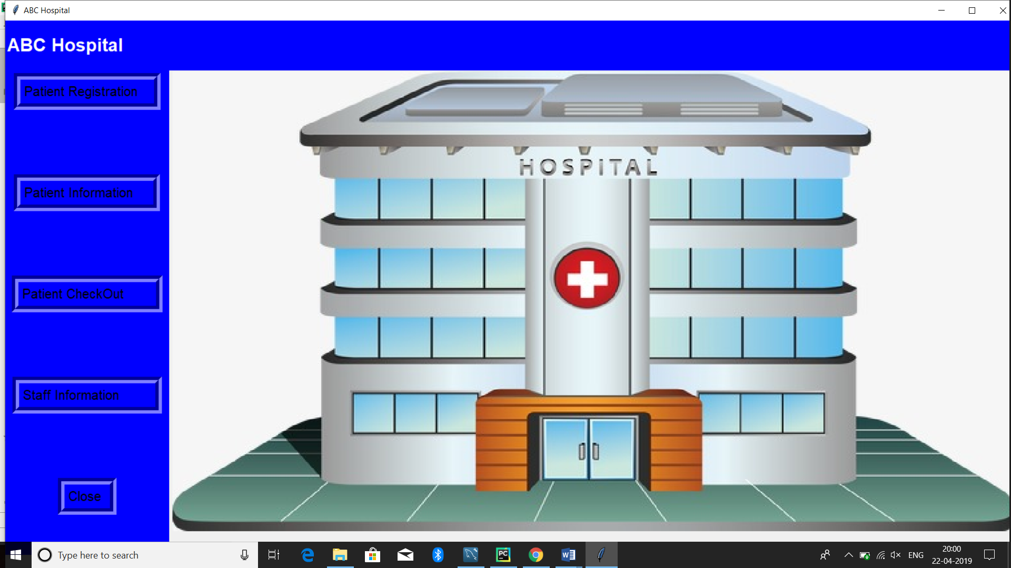

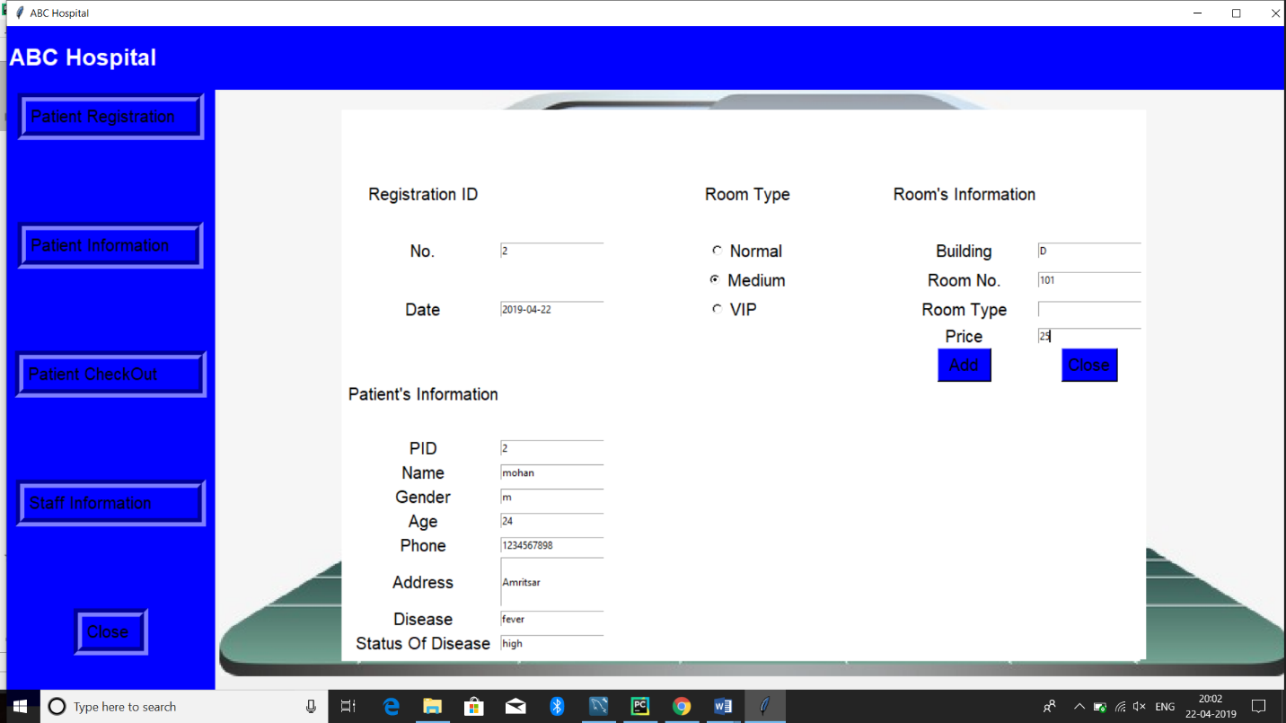

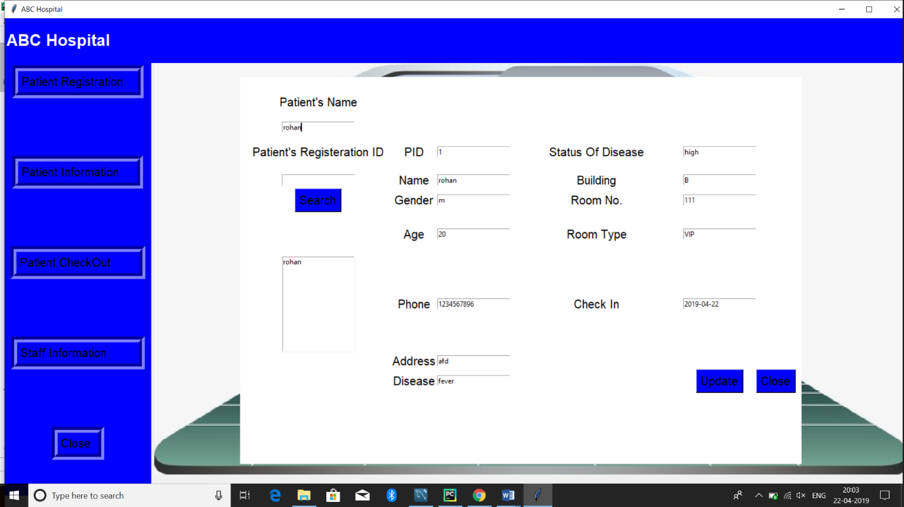

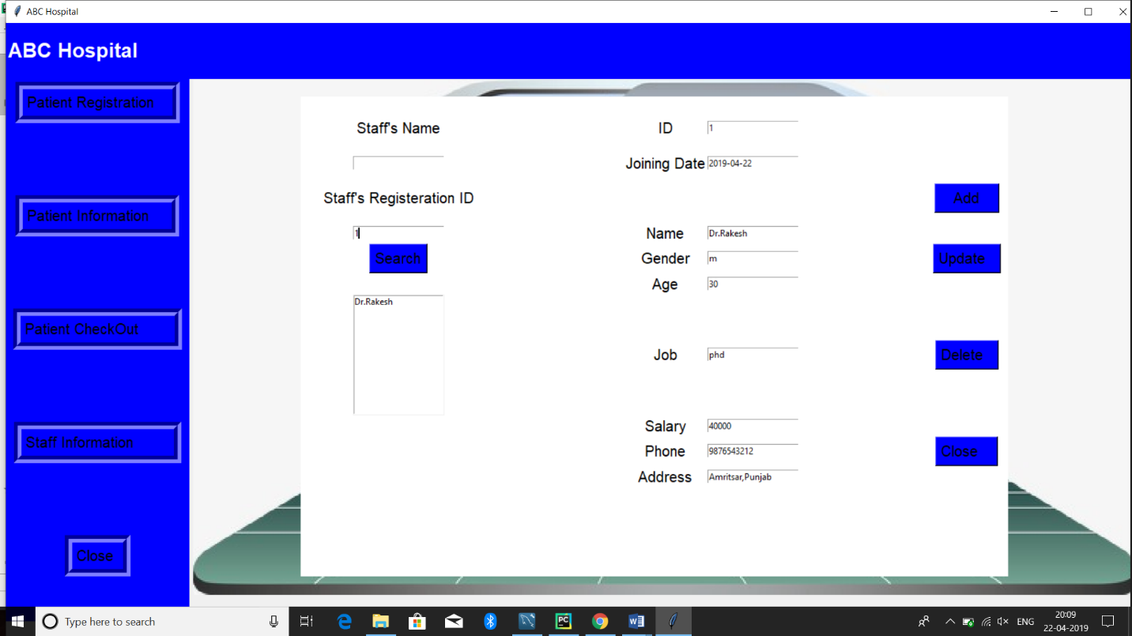

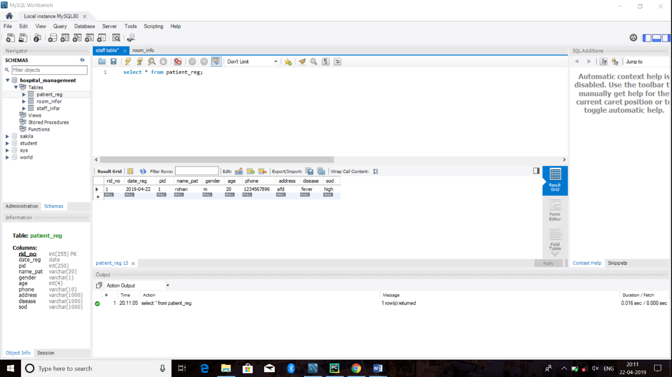

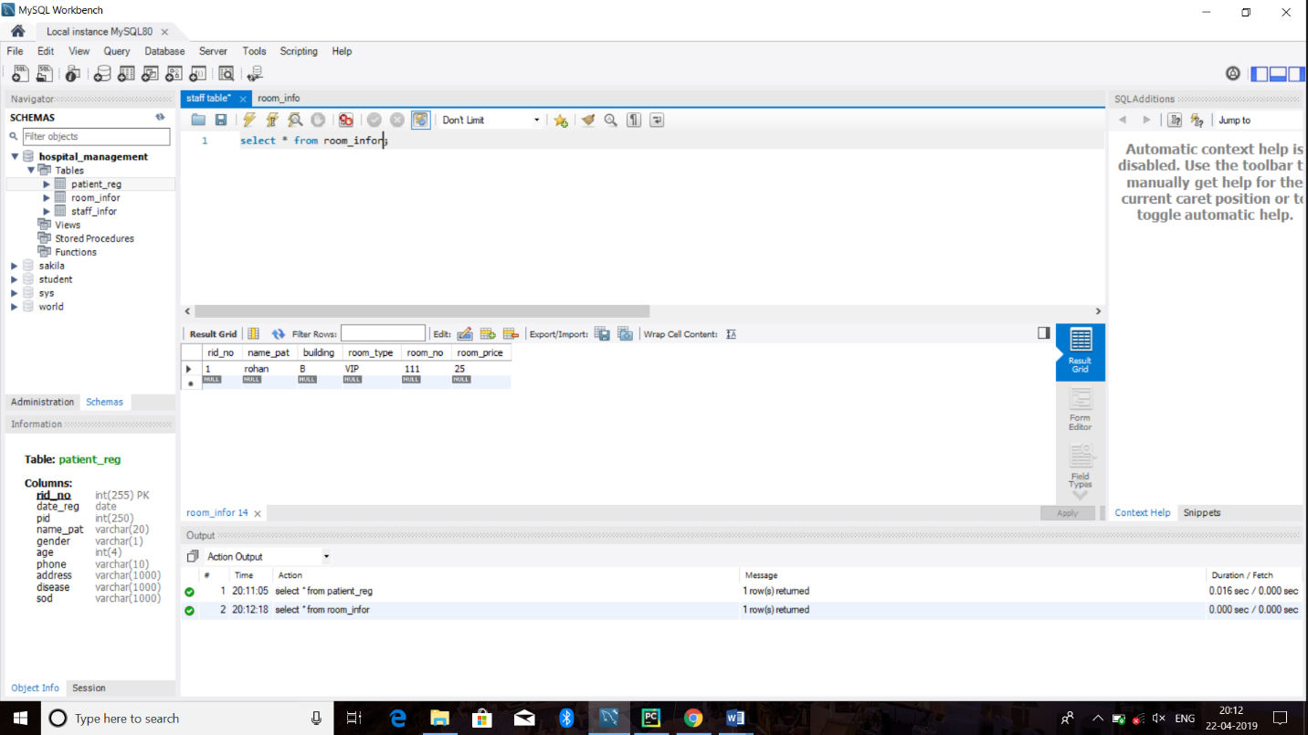

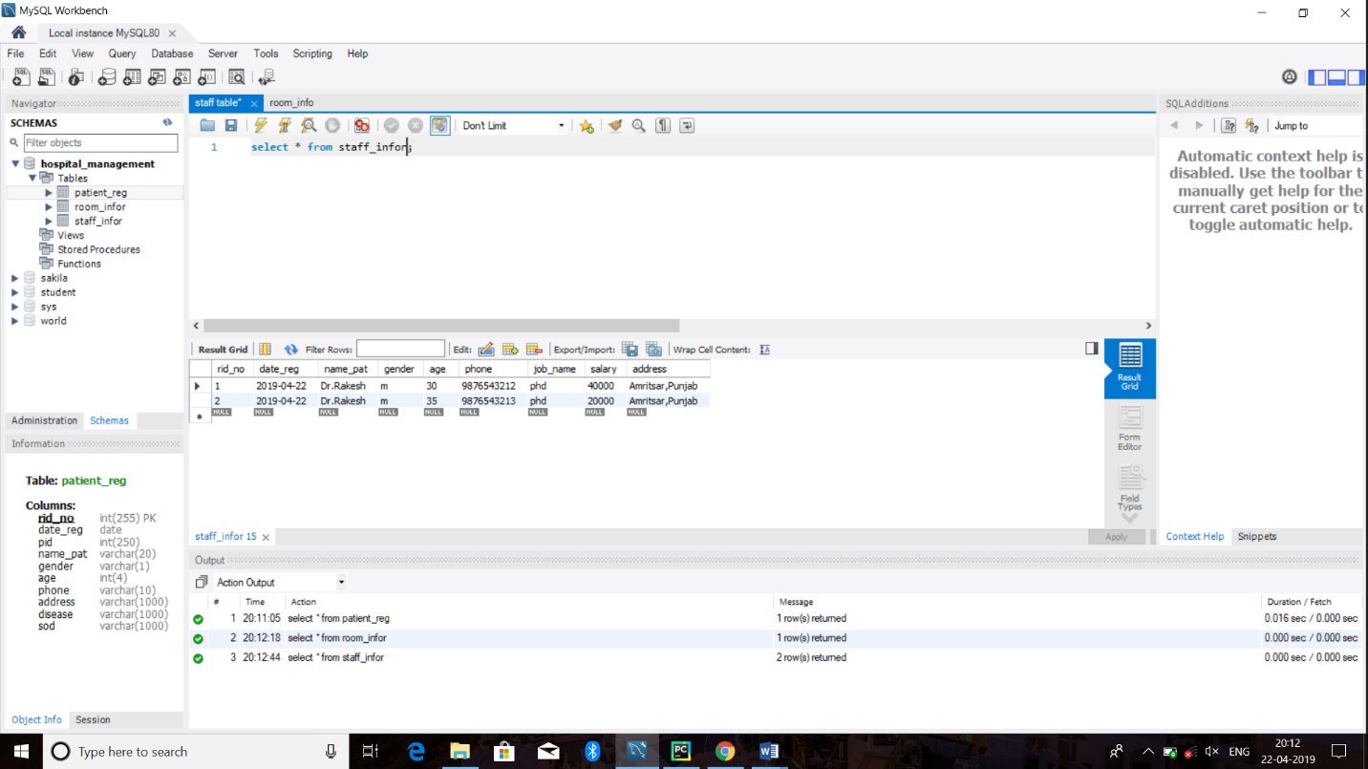

**References**

1. **Books**
2. Ramez Elmasri, Shamkant Navathe ,Fundamentals of Database Systems, Fifth Edition, Pearson Education, 2007.
3. C.J. Date , An Introduction to Database Systems, Eighth Edition, Pearson Education
4. Alexis Leon, Mathews Leon , Database Management Systems, Leon Press.
5. S. K. Singh, Database Systems Concepts, Design and Applications, Pearson Education.
6. **Web URLs**

* <https://www.tutorialspoint.com/sql/sql-rdbms-concepts.htm>[www.tutorialspoint.com/cplusplus/cpp_**files**_streams.htm](http://www.tutorialspoint.com/cplusplus/cpp_files_streams.htm)
* <https://www.geeksforgeeks.org/dbms/>
* <https://www.w3schools.com/sql/>